He’s Macro . He’s come from Italy. He is Khae’s Colleague. He works in marketing.He lives in a studio apartment.He rides motocycle to work when It’s He wants to design a product that everyone can use

He’s John Berry. He’s come from American .He’s Mrs Berry’s son.

He’s Benny’s neighbor. He is a filmmaker.

**She’s Sofi. She is a cook. She works at the restaurant. She takes a bus to work. Her grandmother is a great cook.**

He’s Tod. He’s come from American. He’s 40 years old. His hair is short and gray .He is a supervisor at the Company Company.Khae, Marco and Aanya don’t like him.

She’s Khae. She is come from Thai.She’s a product designer at the company company. Her parents has a noodle shop. She has a brother.

She’s Khae. She is come from Thai.She’s a product designer at the company company. Her parents has a noodle shop. She has a brother.

**She’s Aanya. She is an Engineer.She works at the company company. Her parents lives in India.She has a big family.She has one sister and three brothers.**

**She’s Khae. She is come from Thai.She’s a product designer at the company company. Her parents has a noodle shop. She has a brother.**

**He’s Shen. He lives with Benny. He doesn’t have a job. But He wants to be an actor.**

**Shen was in China before he was in the United States**

**He’s Benny. He lives with Shen. He was a salesperson at a computer store in England.His hobbies is watch football. His mother is a English teacher.**

**1.1**

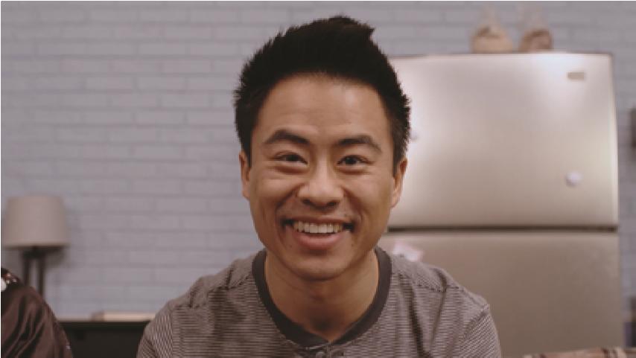

**1**

**/**

**2**

**A**

**2.1**

+



+



+



**2.1**

**B**

***Work with your partner to answer the questions.***

. Your parents’ son is your brother

1

.

2

. Your son’s sister is your daughter

.

3

. Your father’s mother is your grandmother

.

. Another word for “father” is dad

4

.

. Your mother and father are your parents

5

.

. Your sons and daughters are your children

6

.

. Your father’s daughter is your sister

7

.

. Your daughter’s brother is your son

8

.





**3.2**

often

everyday

sometimes

always

never



Do you sometimes ride bicycle on Mondays and Wednesdays



Do you always dink coffee on Monday to Sunday

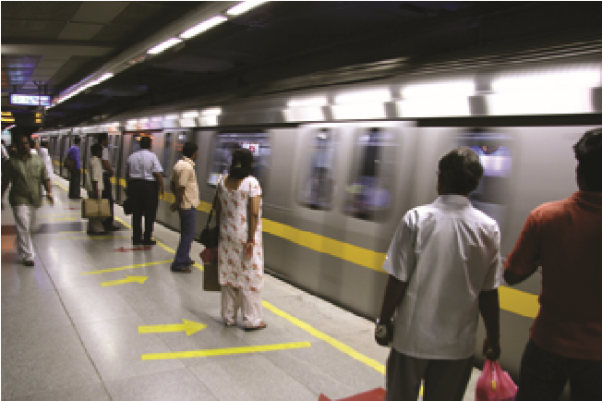

Do you often take the subway from Monday to Sunday



Do you somtimes watch football on Saturdays and Sundays

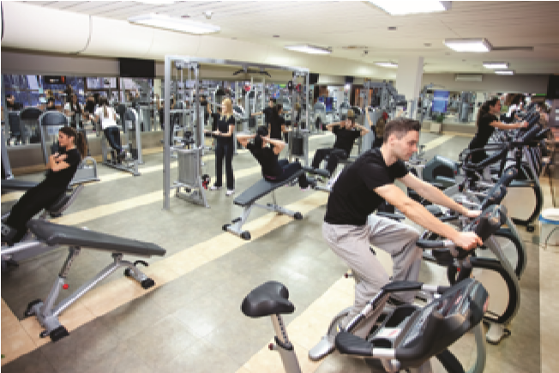

Do you never go to the gym on Saturdays and Sundays



Do you often go to shopping on Fridays



***Use the pictures and time to ask your partner: Do you . . . ?***

Do you drive a car to work on everyday

Do you cook dinner on every day

**3.2**

often

everyday

sometimes

always

never



Mondays and Wednesdays



Monday to Sunday



Monday to Sunday



Saturdays and Sundays



Saturdays and Sundays



Fridays



***Use the pictures and time to ask your partner: Do you . . . ?***

**3.2**

often

everyday

sometimes

always

never



Mondays and Wednesdays



Monday to Sunday



Monday to Sunday



Saturdays and Sundays



Saturdays and Sundays



Fridays



***Use the pictures and time to ask your partner: Do you . . . ?***

